**Analyzing Code in SonarQube using GitHub Actions**

Step 1: In browser Open the SonarQube <https://localhost:9000>.

Step 2; Click on create a Project (Manually).

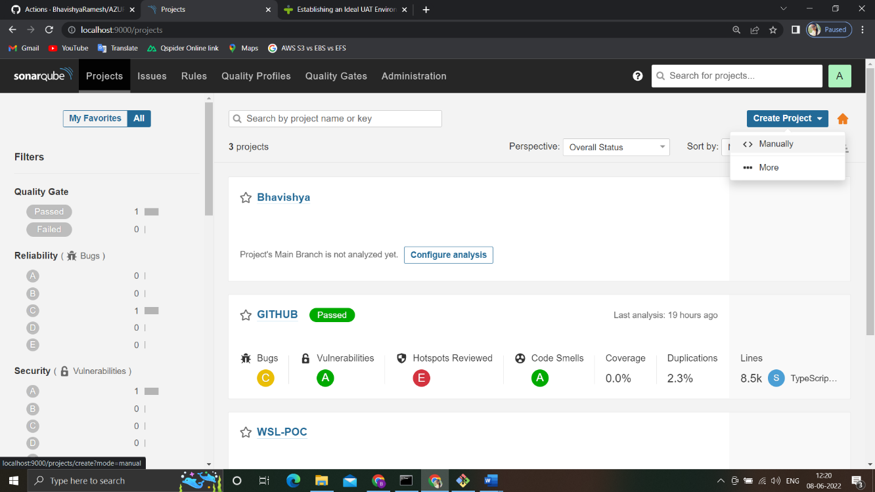

Step 3: Give the name for the project. And next click on Setup

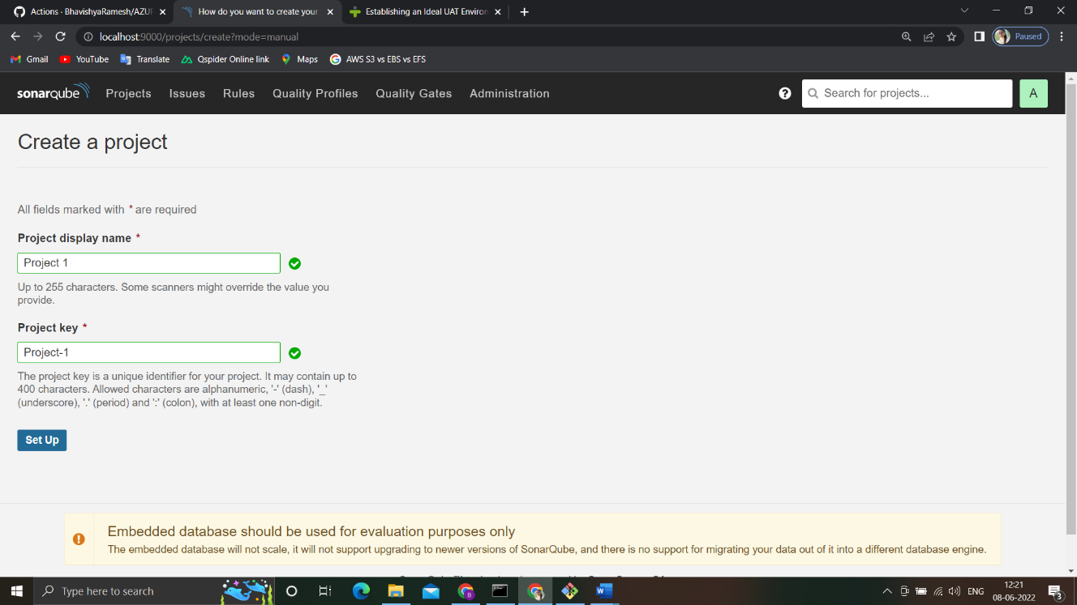

Step 4: You will get a option like

How do you want to analyze your repository.

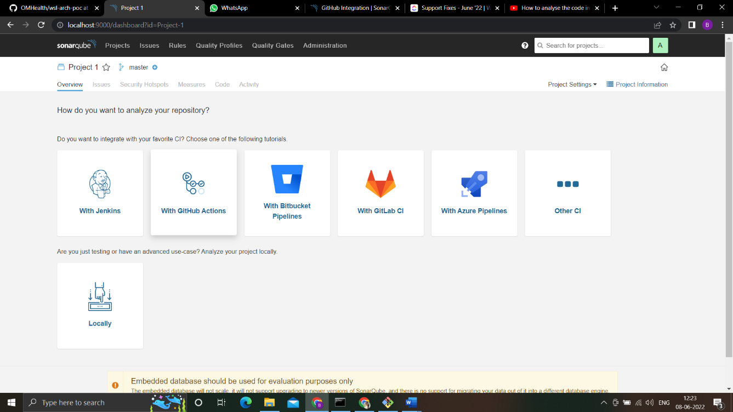

Step 5: Select with GitHub Actions.

Then it will guide you how can you take the code from your repository.

Step 6: Create a GitHub Secrets

We need to create a two New Repository Secrets as in the Screenshot.

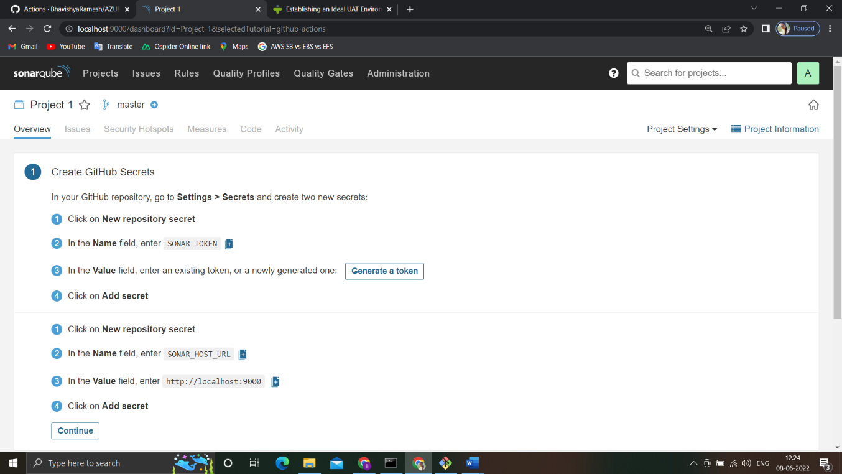

Step 7: Create Workflow YAML file

We will get to choose the programming language for particular language we need to have a particular YAML file.

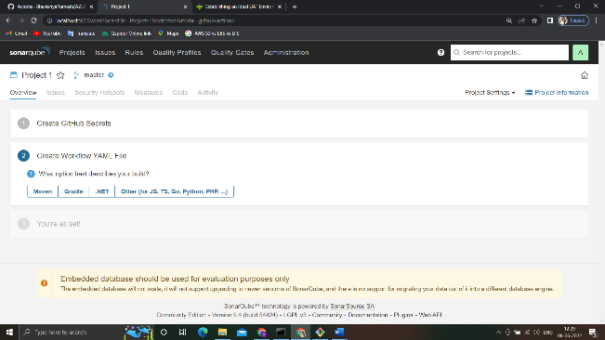 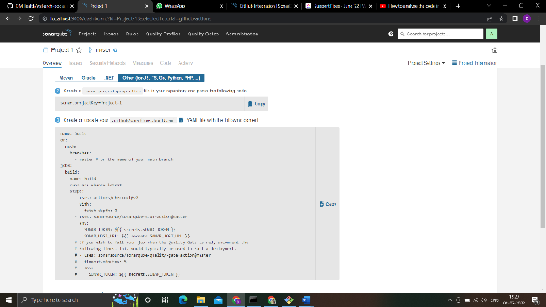

Step 8: Once we commit and push the code to our GitHub repo automatically SonarQube analyze our code.

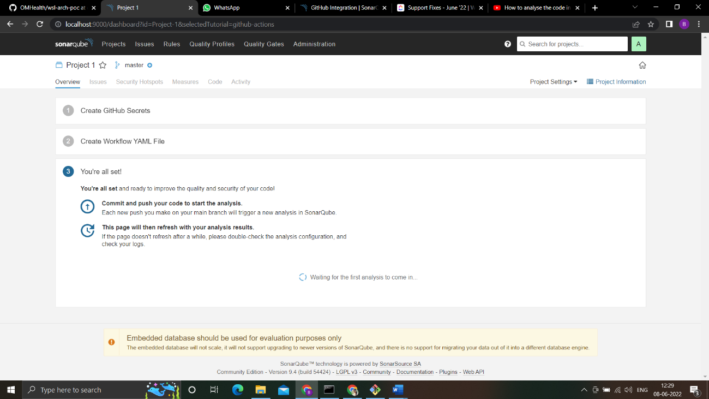

By using GitHub actions we can analyze our source code in SonarQube.